

One step paws – Home

Full stack website

Name : Vasu Dobariya

Roll no. : 22BCE083

Course : Full Stack Web Development

Course Code : 2CS201

Innovative Assignment - Report

Project Github Link: <https://github.com/VASUDOBARIYA/One-Step-Paws-Home>

# Introduction:

The One Step Paws website is a modern and innovative platform that aims to provide comprehensive pet care services to pet owners. The website offers a range of services, including pet grooming, boarding, training, and veterinary care. It also provides a platform for pet owners to connect with service providers and book appointments online. This report provides a detailed analysis of the website's architecture, functionality, user experience, and potential areas for improvement. By examining these aspects of the website, we can gain insights into its strengths and weaknesses, as well as recommendations for enhancing its overall performance and user satisfaction.

# Technologies Used:

Frontend:

The frontend of the website is built using EJS (Embedded JavaScript) for templating, Bootstrap for styling, and JavaScript for client-side interactions.

Backend:

The backend is powered by Node.js with Express.js for routing and middleware, and MongoDB for the database using Mongoose for data modeling.

User Authentication:

User authentication is implemented using session management in Express.js, allowing users to log in and access their dashboard.

Data Modeling:

Mongoose is used to define schemas for user data, service requests, and contact form submissions.

Form Validation:

Form validation is done using express-validator to ensure that user input is correct and meets the required criteria.

Error Handling:

Basic error handling is implemented to catch and log errors that occur during the application's execution.

* The website is built using the Express.js framework for the backend and EJS (Embedded JavaScript) for the frontend templating. Express.js is a popular Node.js framework that provides a robust set of features for building web applications. EJS is used for rendering dynamic content on the frontend, allowing for the creation of dynamic web pages.
* The website's backend is powered by MongoDB, a NoSQL database that provides scalability and flexibility. Mongoose, an Object Data Modeling (ODM) library for MongoDB and Node.js, is used to define schemas and models for interacting with the database. This allows for efficient data storage and retrieval, as well as seamless integration with the Express.js application.

# Features:

User Registration and Login:

Users can register for an account and log in to access their dashboard.

User Dashboard:

Registered users have access to a dashboard where they can view and manage their service requests.

Service Booking:

Users can book pet care services through the website, providing details such as pet name, breed, and requested service.

Contact Form:

The website includes a contact form where users can submit inquiries or messages to the business.

Admin Interface:

An admin interface allows administrators to view and manage service requests and contact form submissions.

# Code Files: Front-end Part

index.ejs: Main homepage template with navigation links and user-specific content.

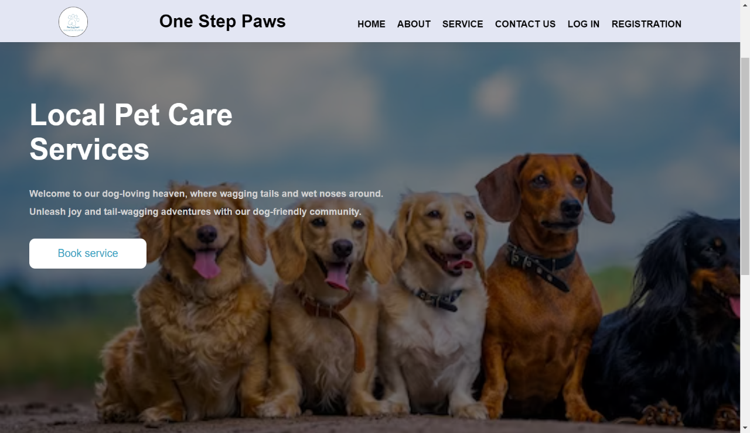

The use of <% if(user_id) { %> and <% } else { %> suggests that you are using a templating engine like EJS or similar to conditionally render content based on whether a user is logged in or not.

Before login:

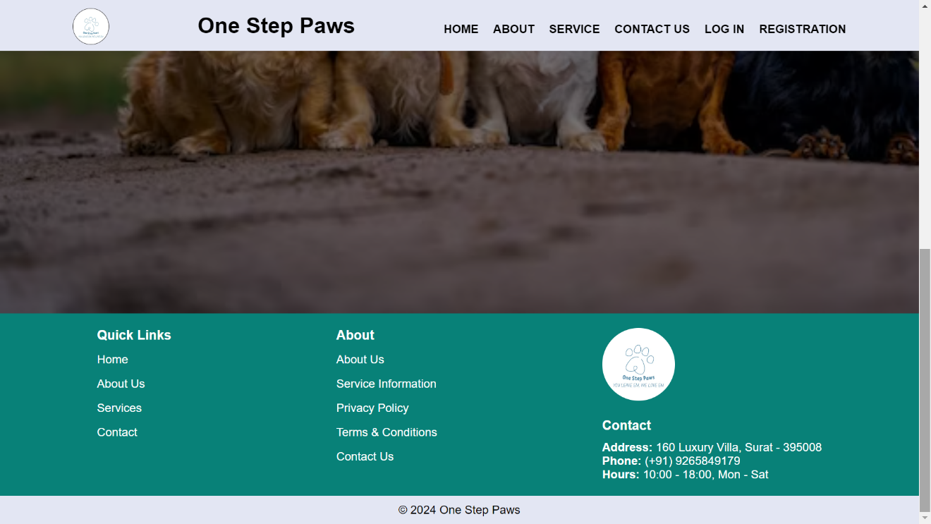

After login:

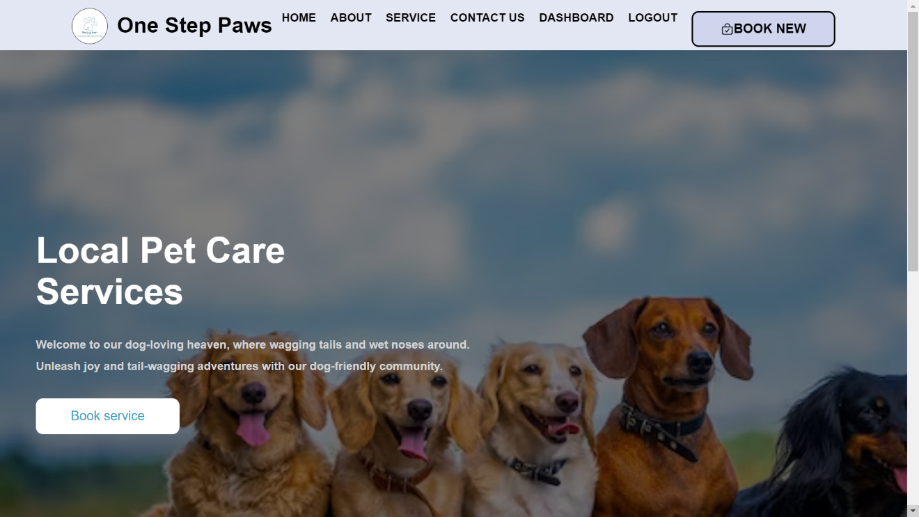

aboutUs.ejs: Template for displaying information about the website and its services.

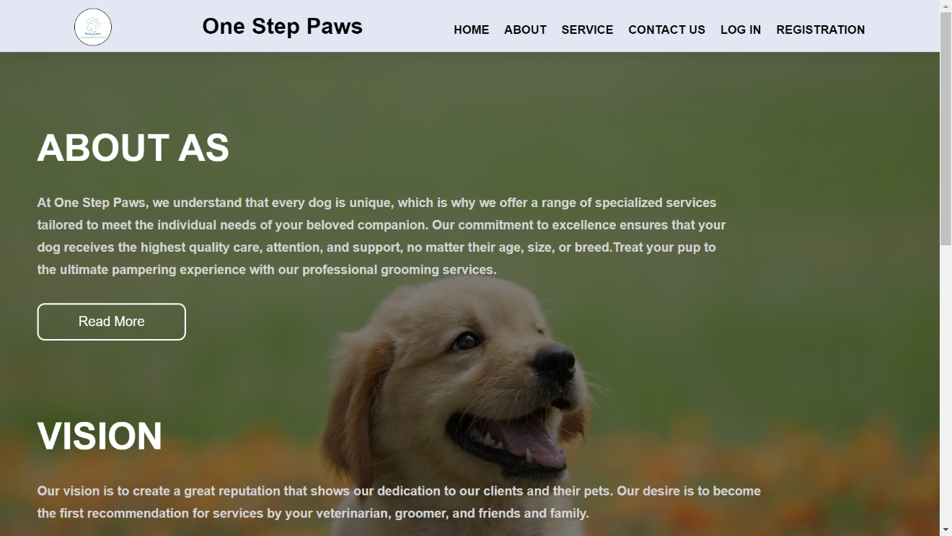

The content in the container and content sections provides a clear overview of your pet care service, including your services, vision, and mission. The footer contains useful links and contact information.

services.ejs: Template for displaying available pet care services. The content in the section elements provides a comprehensive list of services offered by One Step Paws, including dog medical services, theme-based pet care events, pet adventure trips, holistic wellness workshops, grooming, training, and more. Each service is accompanied by a description and an image.

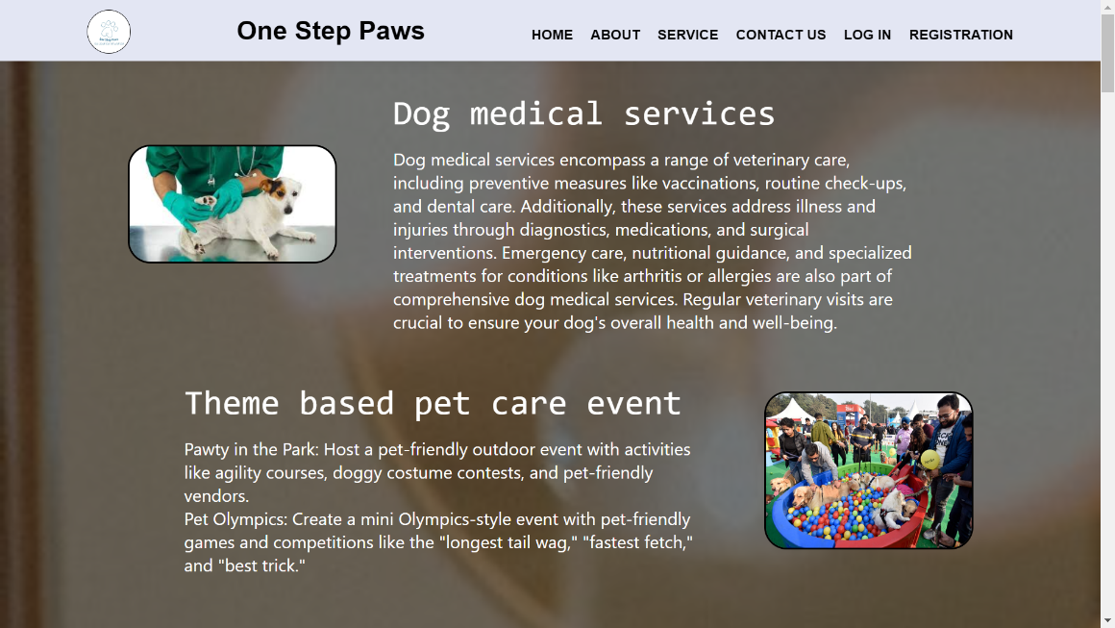

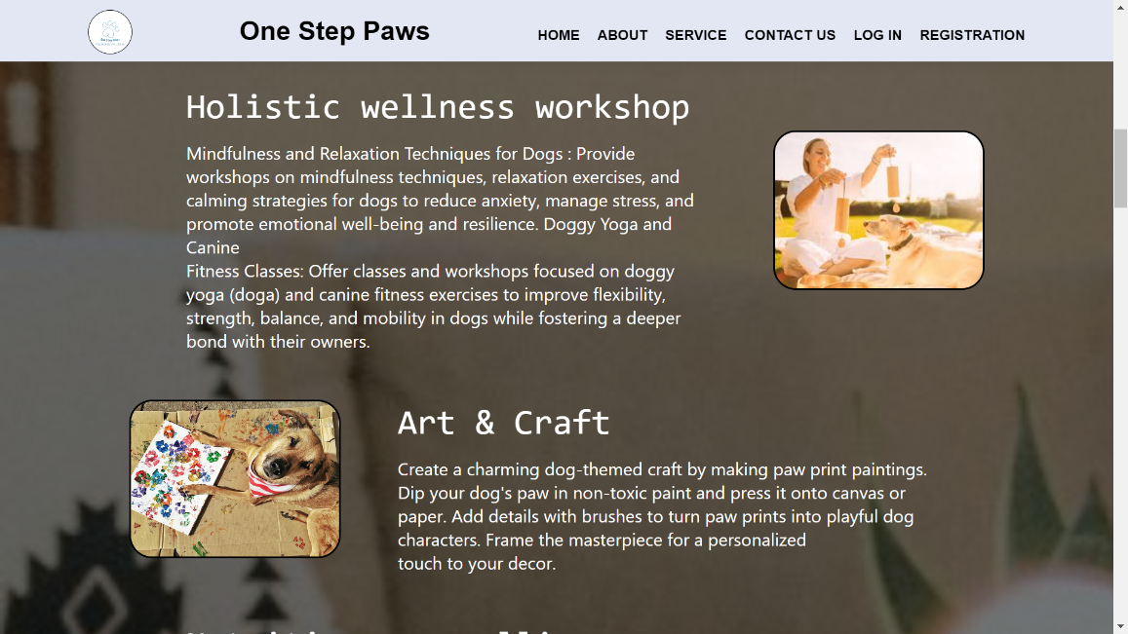

contactUs.ejs: Contact form template for user inquiries.

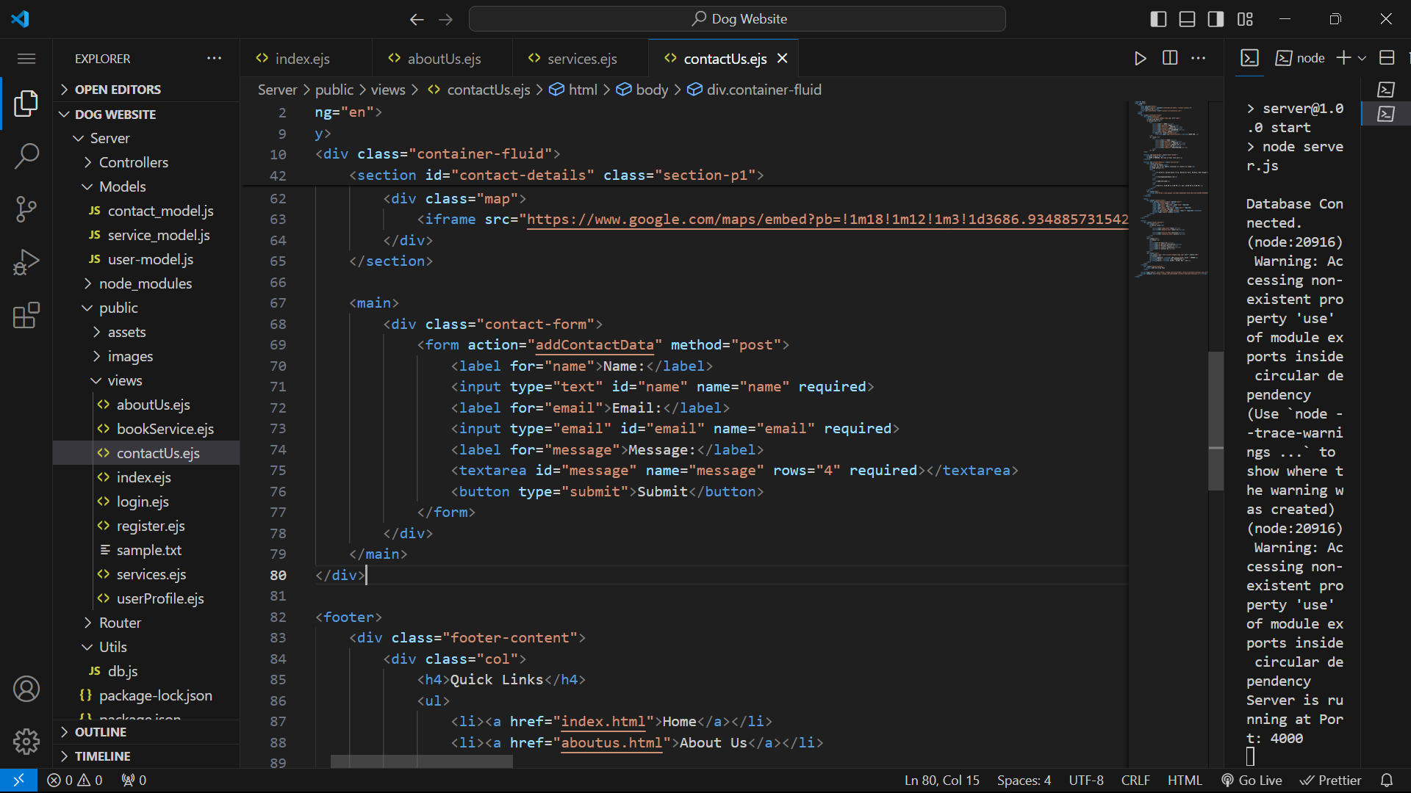

The form element contains the action attribute, which specifies the URL where the form data will be submitted. In this case, the form data will be submitted to the "addContactData" endpoint using the POST method.

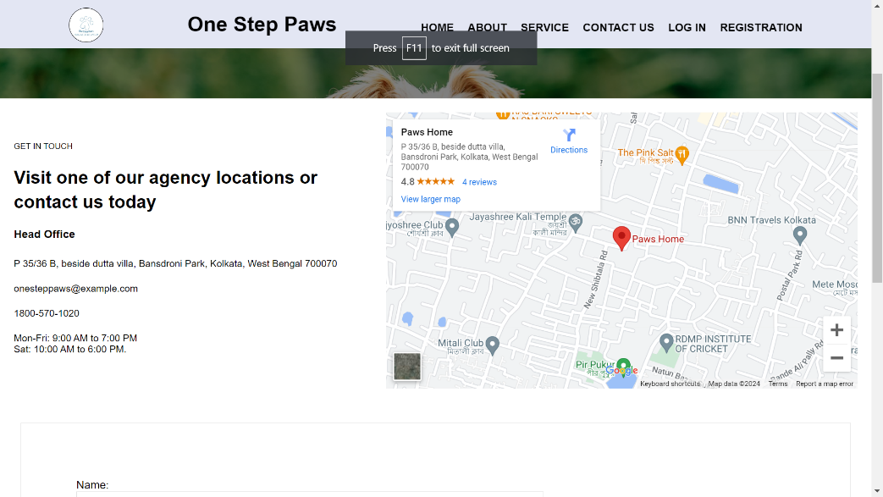

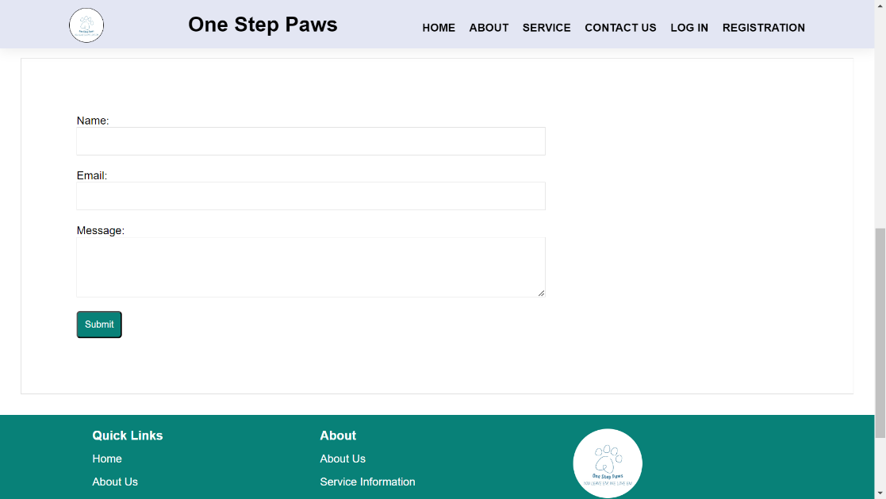

login.ejs: Login form template with error handling for incorrect credentials.

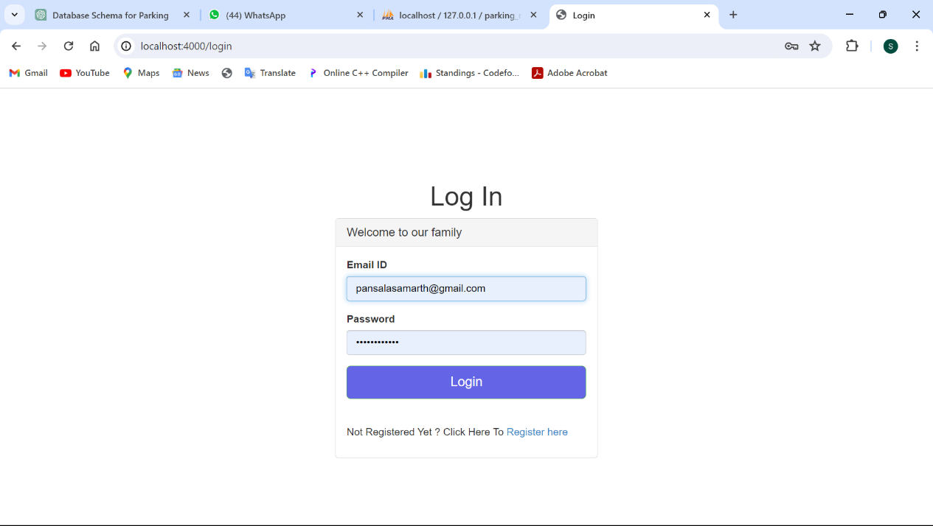

register.ejs: Registration form template with error handling for validation errors.

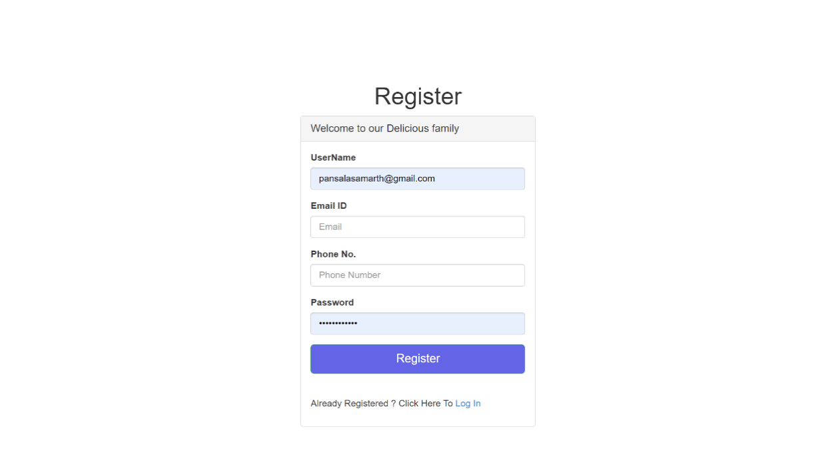

userProfile.ejs: User dashboard template displaying user information and requested services. This code dynamically generates table rows based on the data in the services array. Each row represents an element in the array, and the table cells display various properties of each element.

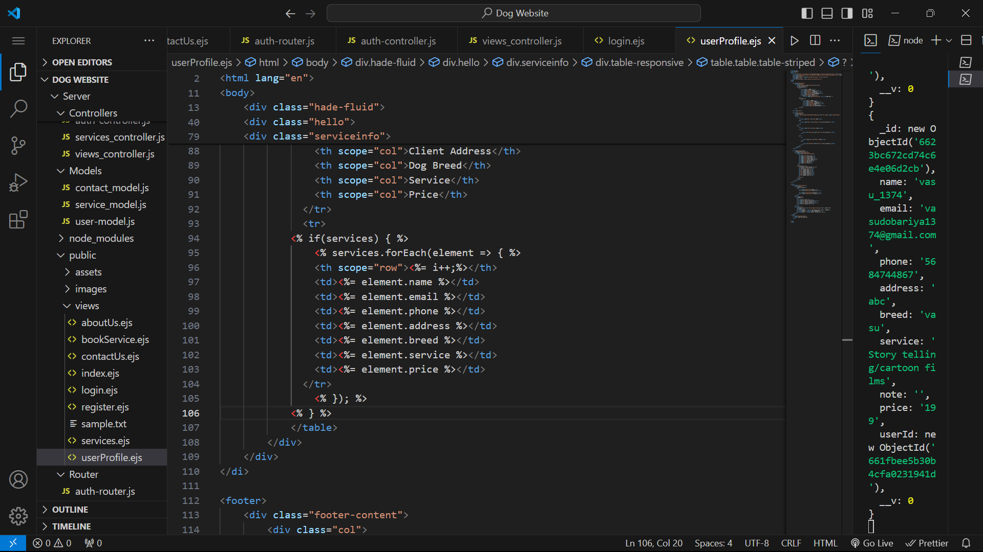

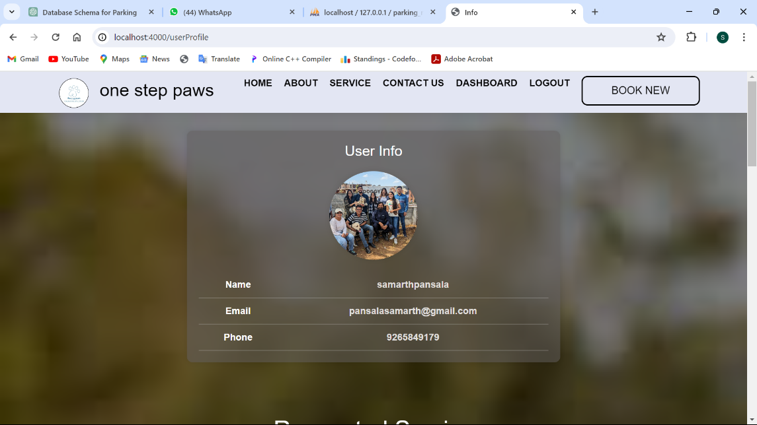

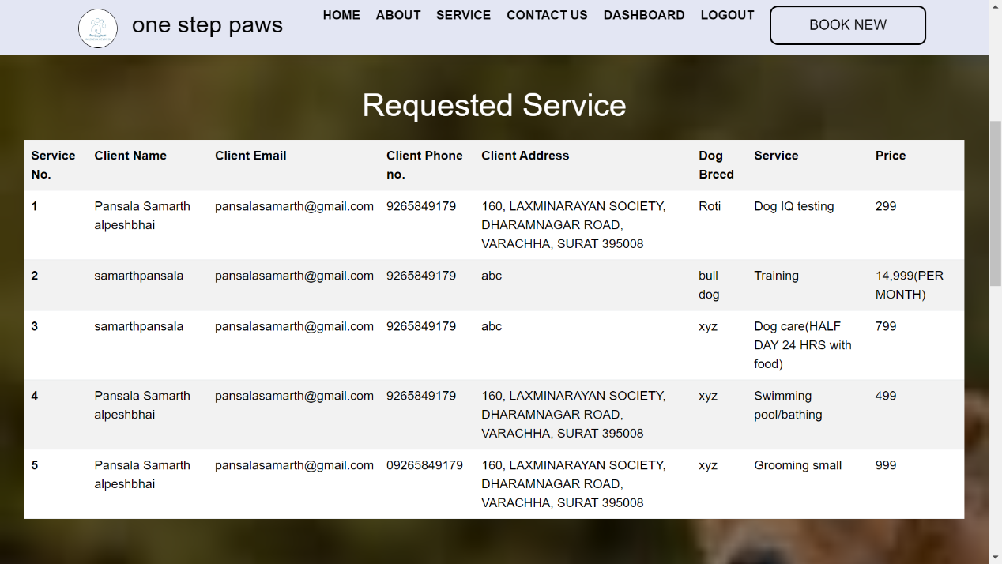

bookService.ejs: Form template for booking pet care services.

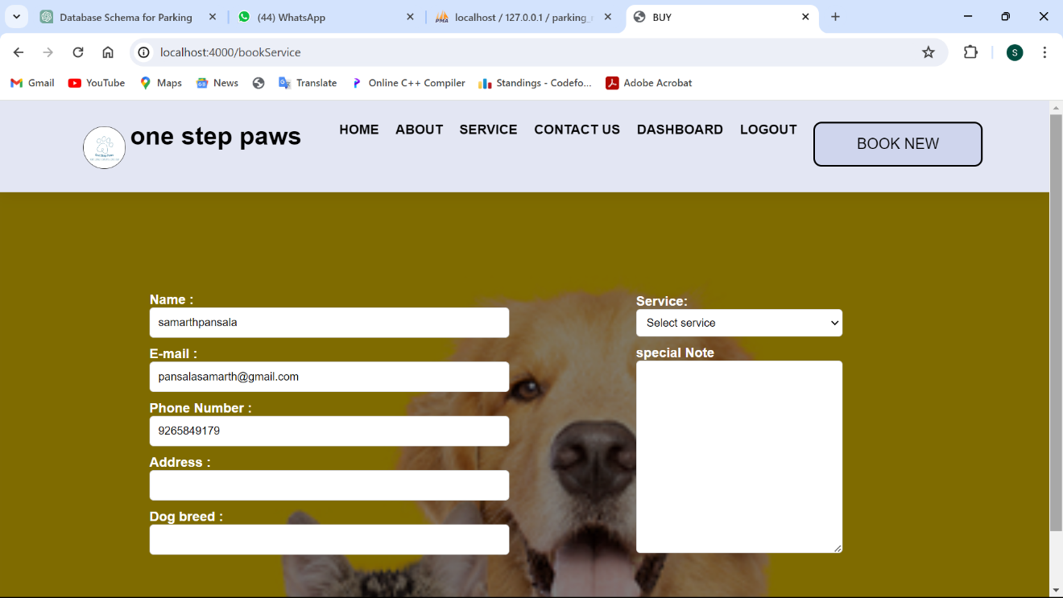

## Database Part :

### Database Connection

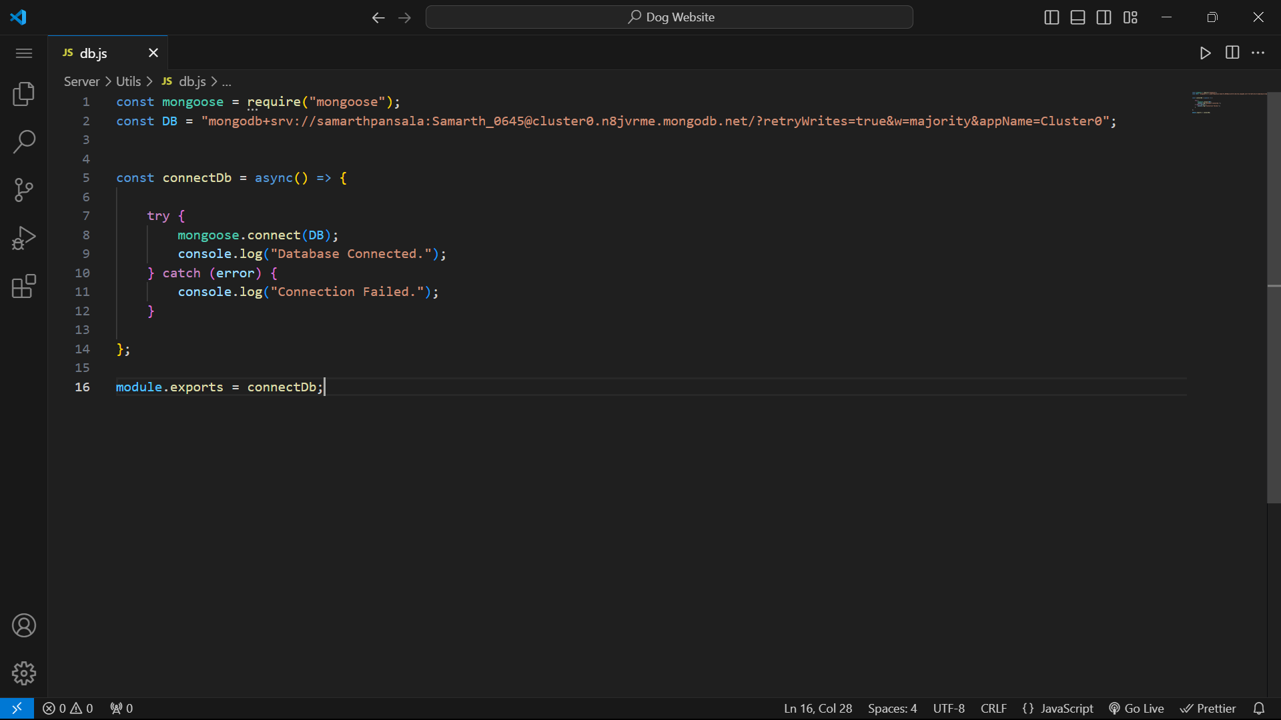

This code snippet is a Node.js module that connects to a MongoDB database using Mongoose, a MongoDB object modeling tool designed to work in an asynchronous environment.

Within this project we have stored a total of three information in the database.

1. User information(when he/she registered)
2. Booked services information
3. Contact information

Their schemas are shown below.

UserSchema : This model represents user accounts in the system. It includes fields such as username, email, phone number, password, and isAdmin flag to indicate whether the user is an administrator.

ServiceSchema : This model represents service requests made by users. It includes various fields such as name, email, phone number, address, service details, price, etc.

ContactSchema : This model represents contacts made through a contact form. It includes fields for the name, email, and message of the contact.

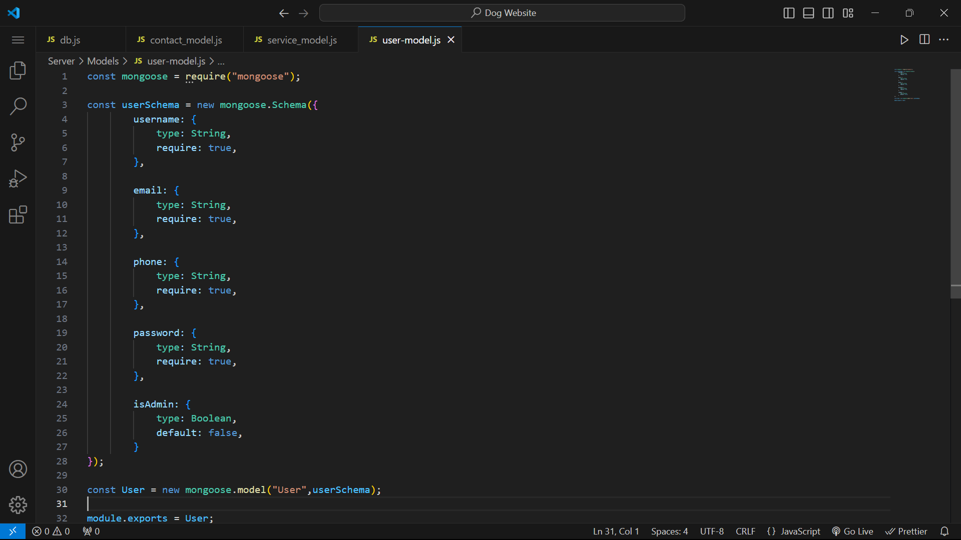 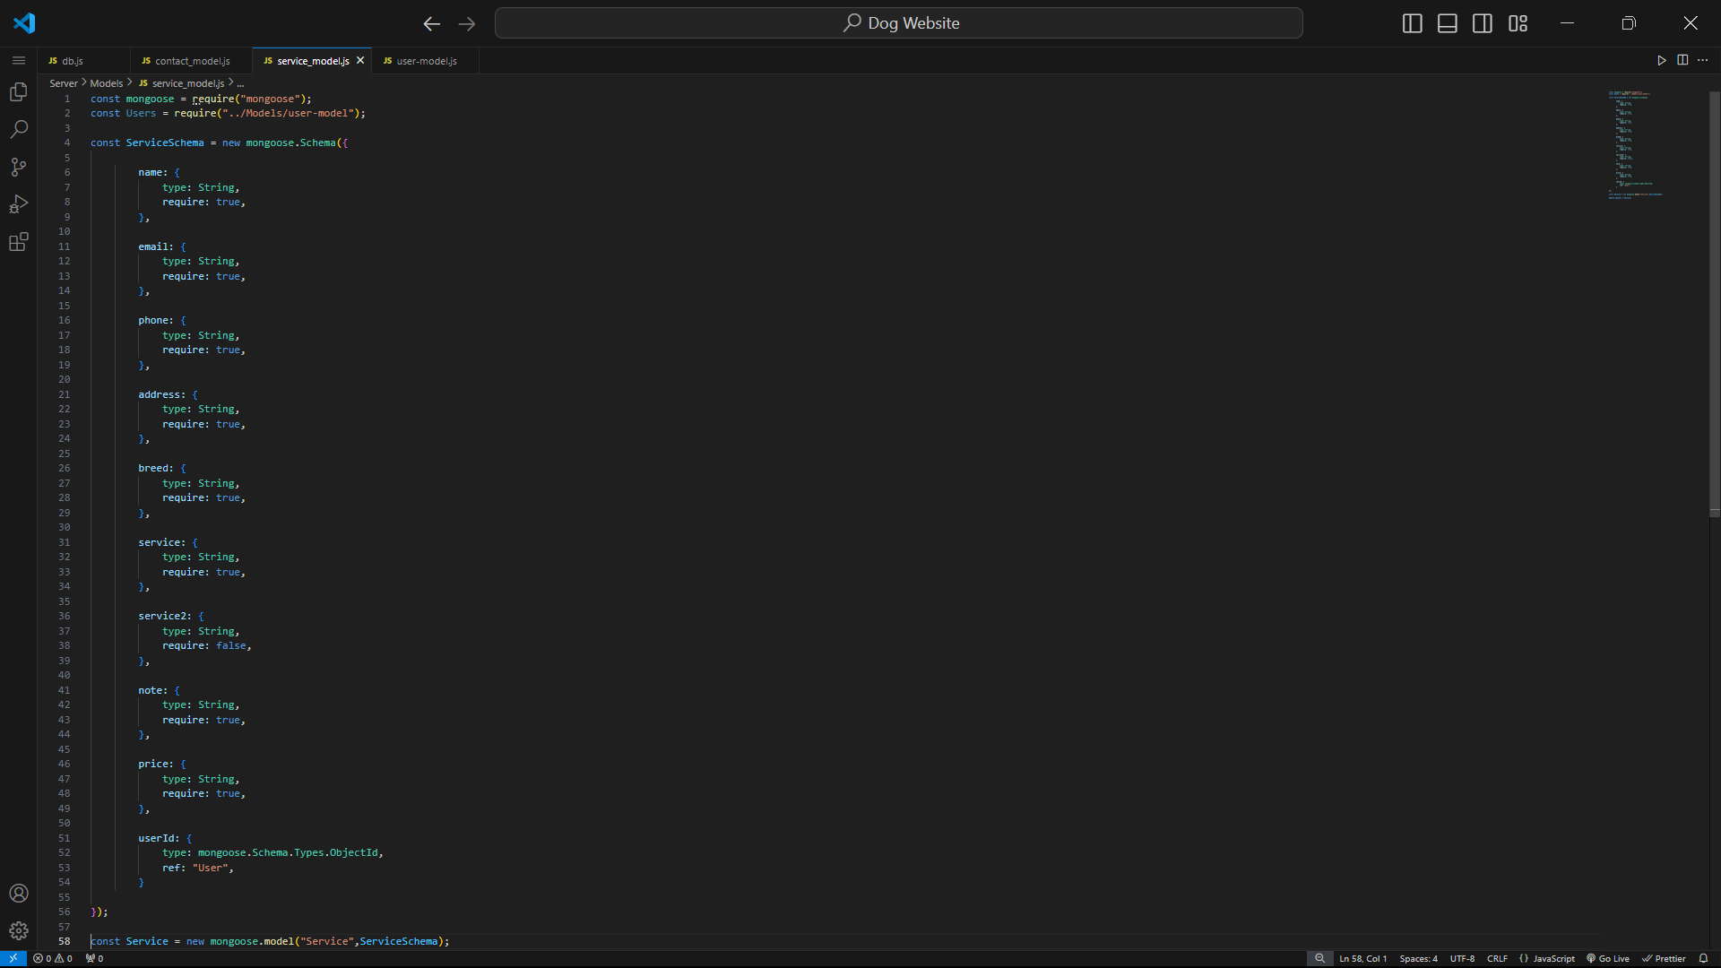

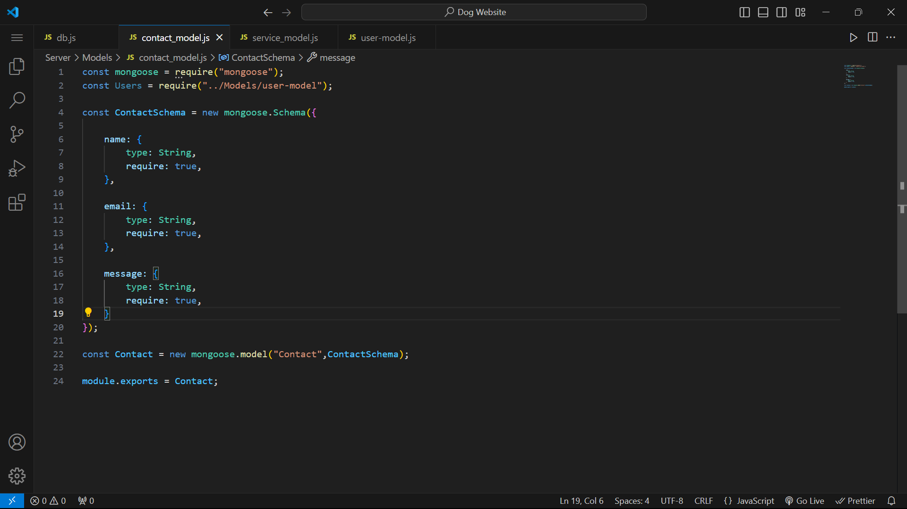

These code snippets define three different Mongoose models: Contact, Service, and User. Each model is defined using Mongoose's Schema and model functions. The module.exports statement at the end of each file exports the respective model so it can be used in other parts of the application.

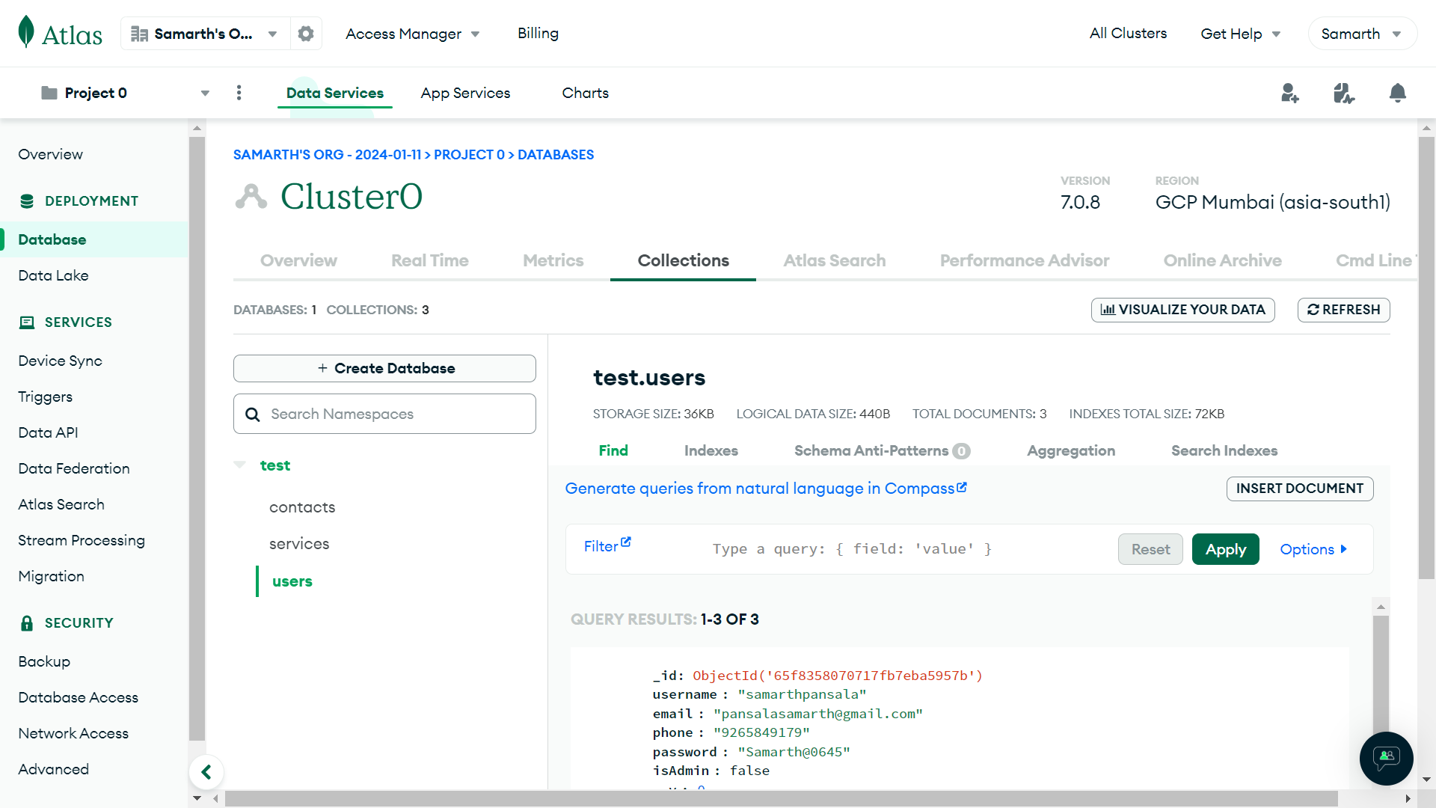

## Backend Part :

To connect the database with front-end, it is required to use backend part. In this project we use express.js as a backend which is a small and intelligent module of node.js

ExpressJS: Express.js is a minimal and flexible Node.js web application framework that provides a robust set of features for building web and mobile applications. It facilitates the development of server-side web applications by providing a simple API for handling HTTP requests and responses, middleware support, and routing.

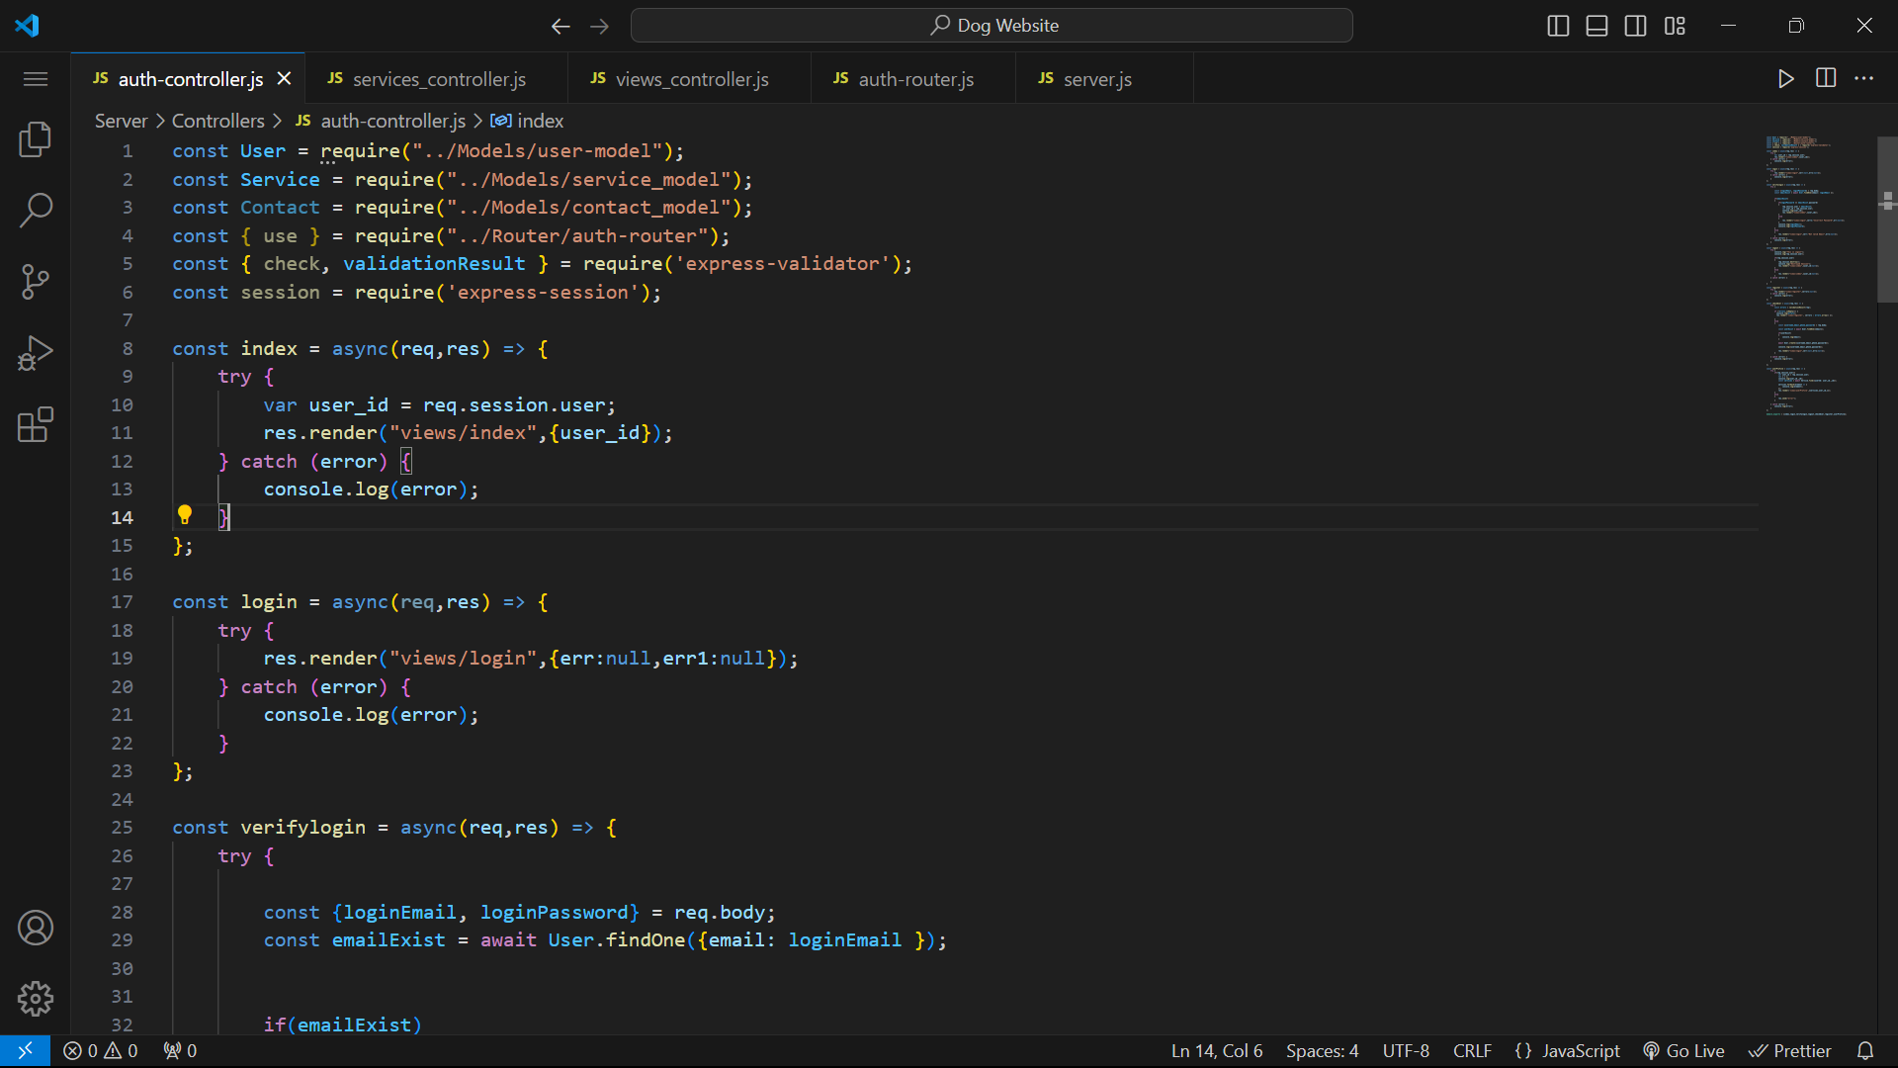

This code snippet requires several modules and models for an Express.js application. These imports suggest that the application uses MongoDB for data storage, uses authentication middleware, and performs input validation using express-validator.

This part defines several routes and their corresponding controller functions for an Express.js application.

Each route handles specific functionalities related to user authentication, profile management, service booking, and contact information.

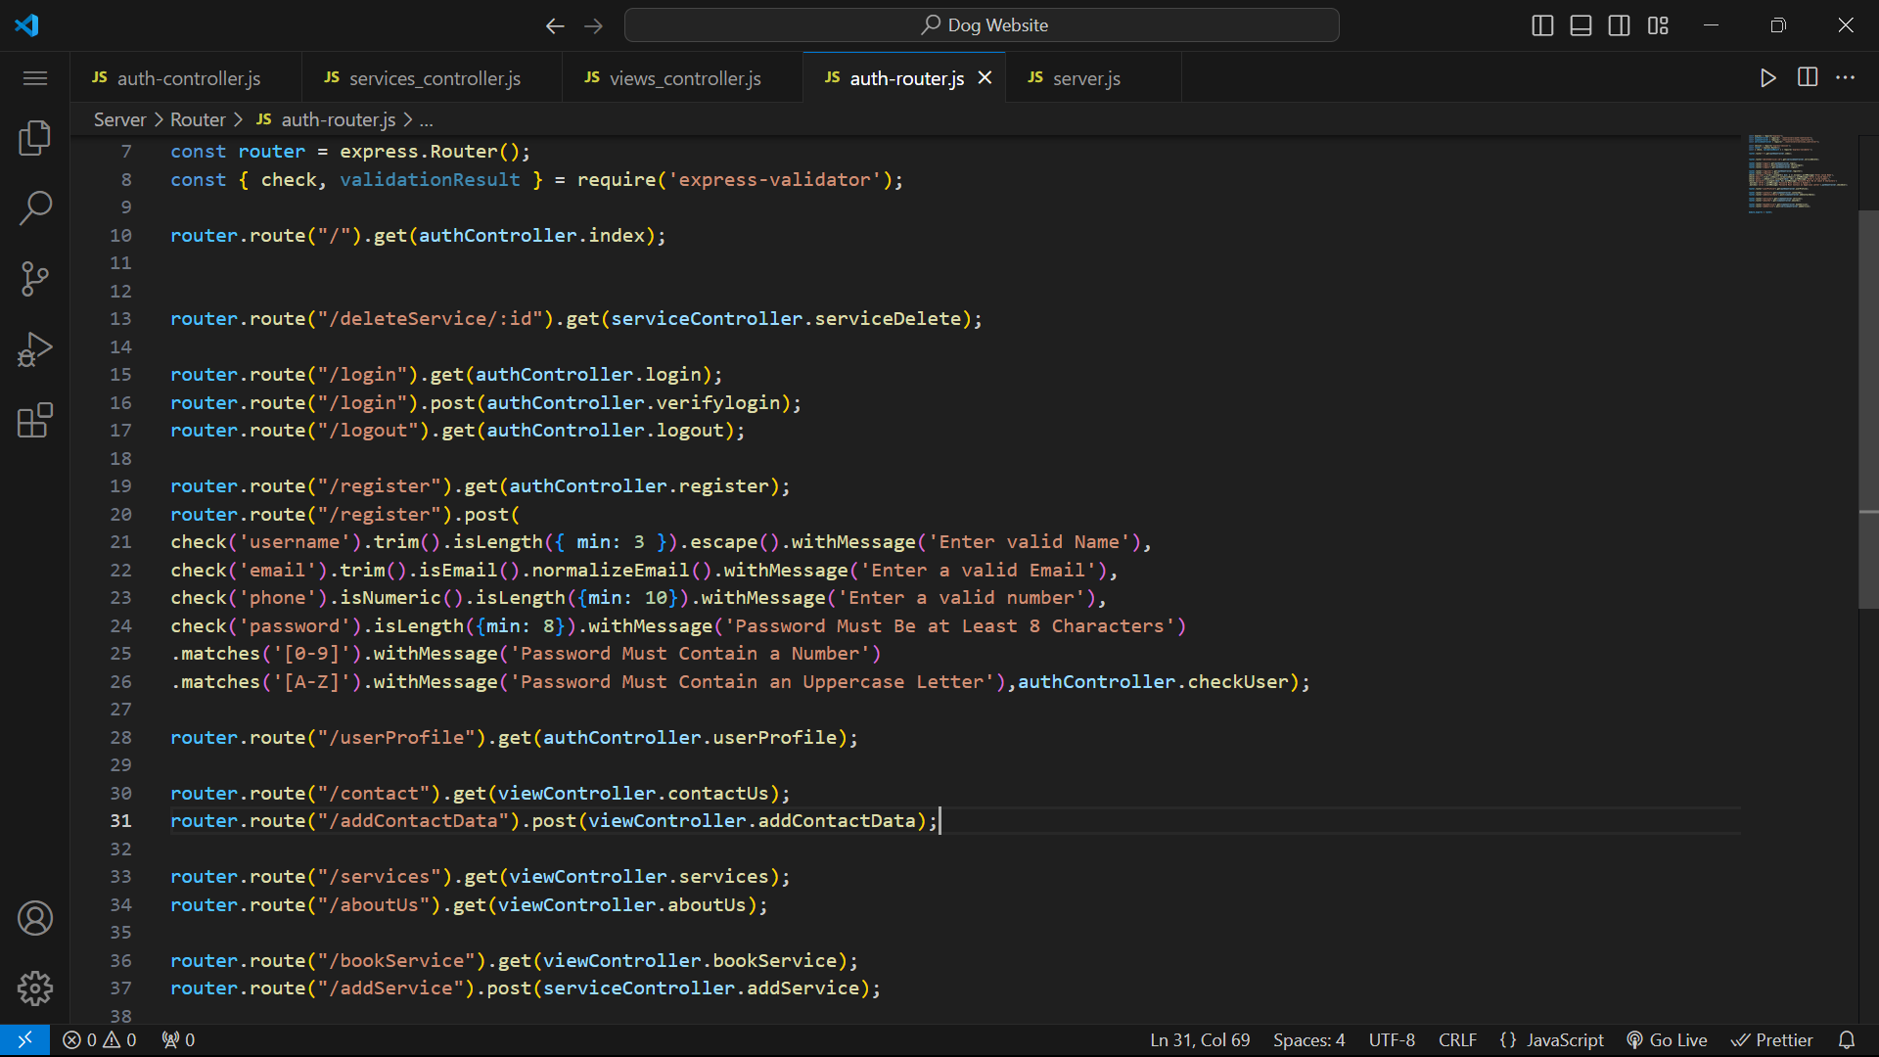

The express-validator middleware is used to validate user input in the registration form. The routes are handled by the respective controllers (auth-controller, views_controller, services_controller). The express-session middleware is used to manage user sessions.

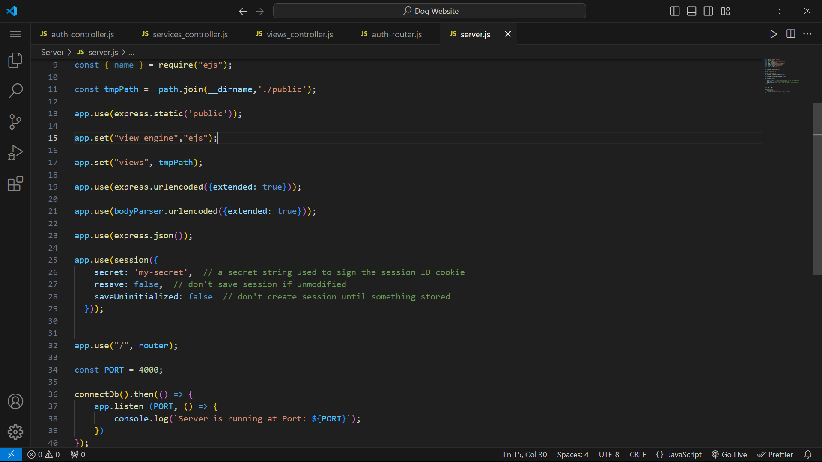



This code sets up an Express server with EJS as the view engine. It serves static files from a public directory, parses URL-encoded and JSON request bodies, and uses express-session for session management. The server listens on port 4000 and uses a router defined in auth-router for routing. Finally, it connects to a database using connectDb.

## Code Overview:

* The website is built using the Express.js framework for the backend and EJS for the frontend templating.
* User authentication is implemented using sessions, allowing users to log in and access their dashboard.
* The website includes features such as service booking, contact form submission, and user registration.
* Data is stored in a MongoDB database using Mongoose for data modeling and querying.
* Form validation is implemented using express-validator to ensure data integrity and security.
* The website is designed to be responsive and user-friendly, with a clean and modern interface.

# Conclusion:

In conclusion, the One Step Paws website is a well-designed and functional platform that offers a range of pet care services to pet owners. By analyzing its architecture, functionality, user experience, and potential areas for improvement, we can gain valuable insights into how the website can be enhanced to better serve its users and achieve its goals. With continued development and refinement, the website has the potential to become a leading platform in the pet care industry, providing valuable services to pet owners and service providers alike.